REPRODUCTION IN PORIFERA:
Sponges reproduce both asexually and sexually and they also possess the power of regeneration due which it is almost impossible to kill a sponge. Their sexual reproduction is similar to higher animals even though their body organization is primitive type.
ASEXUAL REPRODUCTION
Regeneration
All sponges possess a remarkable ability to regenerate lost parts. A piece cut from the body of a sponge is capable of growing into a complete sponge. If a sponge is cut into small pieces and squeezed through a fine silken mesh to separate cells, the separated amoebocytes will reunite and in a few days will develop canals, flagellated chambers and skeleton and grow up into a new sponge. This power of regeneration helps the sponges to repair the damage caused in the harsh environment.
Budding & Branching
In budding, numerous archaeocytes gather near the surface resulting in a small outgrowth on the pinacoderm. The bud thus formed grows outward to produce a small individual, which either remains attached with the parent individual or gets detached and
grows by branching and secondary branching and many small vertical buds grow out of it.
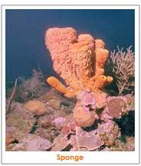
Fission & Fragmentation
In some sponges multiplication takes place by developing a line of fission and throwing off parts of the body which later can develop into a new sponge. Sponges can break into several pieces along several lines of weakness and breaking into fragments that are capable to tide over unfavourable environmental conditions and grow into complete sponges in the following favourable season.
Reduction bodies
Many fresh water and marine sponges disintegrate in adverse environmental conditions particularly in winter, leaving small rounded balls called reduction bodies. Each body consists of an internal mass of amoebocytes, covered externally by a pinacoderm and spicules. When favourable conditions return, these reduction bodies grow into complete new sponges.
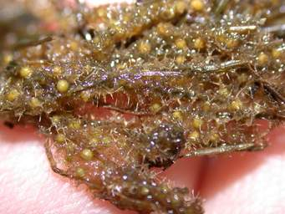

Gemmules
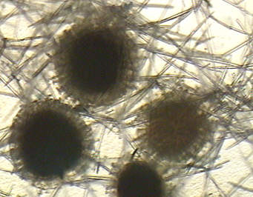

Fresh water sponges such as Spongilla as well as some marine forms such as Ficulina, Suberites, and Tethya possess the remarkable ability to produce specialised bodies called gemmules, which survive during unfavourable conditions and germinate to produce new sponges. For gemmule formation, archaeocytes laden with food material in the form of glycoprotein or lipoprotein get aggregated into a mass. Amoebocytes surround the central mass of archaeocytes and secrete a thick hard chitinous inner layer and an outer membranous layer over it. Scleroblasts secrete amphidisc spicules between the inner and outer membranes. A fully formed gemmule is a small hard ball having a mass of food laden archaeocytes enclosed in a double layered tough envelope with amphidisc spicules in between. There is a small opening the micropyle through which the cells come out during development in favourable conditions.
In autumn fresh water sponges die and disintegrate, leaving behind a large number of gemmules, which remain viable throughout the winter. Same thing happens during summer when water available is low. In favourable conditions with abundance of water the gemmules begin to hatch and their living contents escape through micropyles and develop into new sponges by collecting themselves together.
SEXUAL REPRODUCTION
Sexual reproduction involves formation of sperms and ova. The sex cells arise either from archaeocytes or choanocytes. Although most sponges are hermaphrodite but cross-fertilization is the rule because eggs and sperms are produced at different times.
Oocytes are produced inside the body and remain inside mesogloea waiting for fertilization. In sperm formation, archaeocyte and trophocyte cells are involved and in demospongiae choanocytes form sperms and leave the body of sponge through osculum in large numbers.
Sperms from water enter the body of another sponge through canal system and reach the flagellate chambers, where choanocytes trap them. Acting as nurse cells, choanocytes transport the sperm body without tail to the mature ova that wait in the mesogloea. The sperm nucleus then fuses with the nucleus of ovum, ensuring internal fertilization.
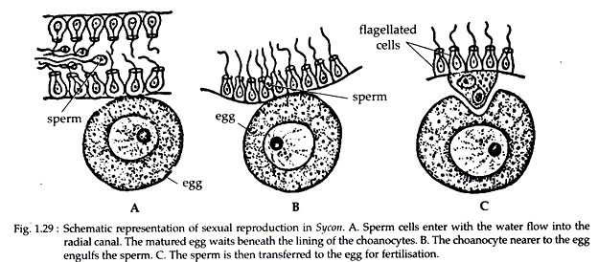

LARVAL DEVELOPMENT
Early development takes place within maternal sponge body leading to the formation of a larval stage. Cleavage is holoblastic and radial forming different types of blastula and gastrula.
Development in syconoid sponges
In syconoid sponges the larva produced is called stomoblastula, since it has a mouth and feeds on nurse cells within mesogloea and grows for a few days. Stomoblastula after growing changes into amphiblastulaby inverting inside out bringing the flagellated cells on the outer surface so that the larva can swim in water. Amphiblastula leaves the sponge body and swims freely in water feeding on micro-organisms.
Gastrulation is by invagination of micromeres, bringing the flagellated cells again inside the body, lining a cavity which later becomes spongocoel. Cells on the outer surface transform into pinacocytes.
Gastrula swims about and settles on a rock with blastopore against the rock and grows to form olynthusstage that looks like a little sponge. An osculum is formed later.
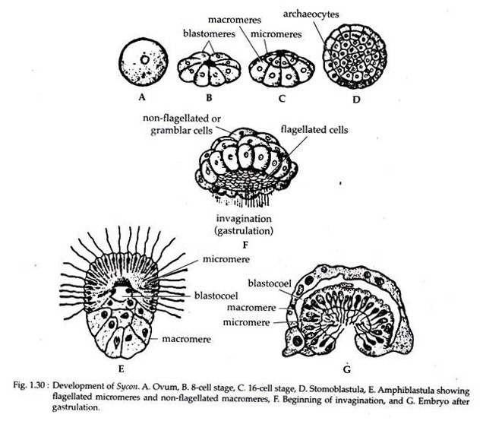
Development in asconoid and leuconoid sponges
In asconoid and leuconoid sponges, the blastula is called coeloblastula as it does not possess a mouth but has a blastocoel and flagella on the surface of the body. This larva escapes from the sponge body and swims about freely in water.
Gastrulation takes place by delamination of the archaeocytes which are located on one end of the blastocoel. The archaeocytes gradually fill the blastocoel completely and the gastrula becomes solid. This solid gastrula is known as stereogastrula, parenchymula or parenchymella, which swims about for some time and then settles on substratum to form olynthus stage. The inner archaeocytes migrate to form pinacocytes on the surface and the outer flagellated cells migrate towards inside to form choanocytes lining the spongocoel.
Development with Rhagon larva
In Spongilla, the larva is different from parenchymula and it is called rhagon larva, which has a tent-like body with a broad flat base called hypophare and a conical body called spongophare, with a narrow upper end on which is located the osculum. There are flagellated chambers which open to the outside by ostia and into the spongocoel by apopyles. The sedentary larva grows to become adult.

